**Instagram User Analytics Project**

**Purpose**

The goal of this project is to study and analyse the user behaviour on Instagram and give insights to the stakeholders.

The project will identify the ways to derive business insights for marketing, product & development teams. Through this project, we will gain the knowledge about user behaviour and the engagement over the platform.

The final deliverable will recommend the most used hashtags, bot users and days to run the successful ad campaign.

**Database**

In order to draw meaningful conclusions that could be used for further decision making.

I had to collect data first. So, for that the commands were run from the following attachment:

<https://docs.google.com/document/d/1-WhNRX1iYJIz7e5l28DMPWgsPklpE_w6/edit>

in order to get a better understanding of the target audience and their needs. I also had to analyse the collected data

To complete this project the software used is DATABASE: MySQL v5.7 as it is easy to use and understandable.

**Approach:**

The main objective was to understand how they interact with our product. To do this, I analysed data from the database provided. By understanding our users' needs, we can create a product that is tailored to their needs and make sure that it meets all their expectations. Additionally, I wanted to use this project as an opportunity to learn more about user experience design principles so that I can apply them in future projects.

**Marketing**

1. **Top 5 oldest users**

SELECT *

FROM ig_clone.users

ORDER BY created_at

LIMIT 5;

**Result:**

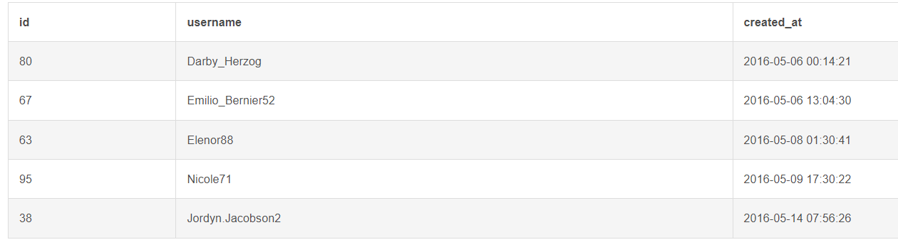

1. **Remind Inactive Users to Start Posting**

SELECT

users.id,

username,

users.created_at

FROM ig_clone.users

LEFT JOIN ig_clone.photos

ON users.id = ig_clone.photos.user_id

WHERE ig_clone.photos.user_id IS NULL;

**Result:**

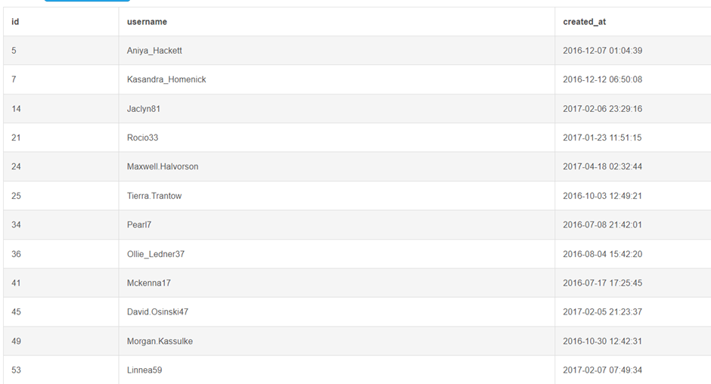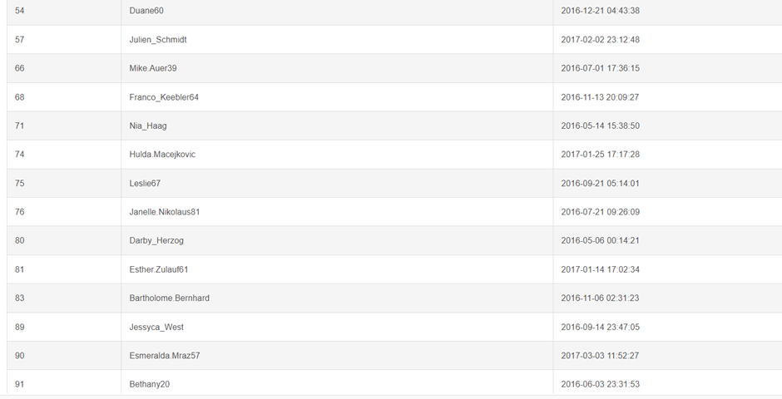

1. **Contest Winner**

SELECT

users.id AS user_id,

username,

photos.id AS photo_id,

photos.image_url,

COUNT(*) AS total_likes_count

FROM ig_clone.photos

JOIN ig_clone.likes

ON photos.id = likes.photo_id

JOIN ig_clone.users

ON users.id = photos.user_id

GROUP BY photos.id

ORDER BY total_likes_count DESC

LIMIT 1;

**Result:**



1. **Hashtag Researching**

SELECT

ig_clone.tags.id AS tag_id,

ig_clone.tags.tag_name,

COUNT(*) as total

FROM ig_clone.tags

JOIN ig_clone.photo_tags

ON ig_clone.tags.id = ig_clone.photo_tags.tag_id

GROUP BY ig_clone.tags.id

ORDER BY total DESC

LIMIT 5;

**Result:**

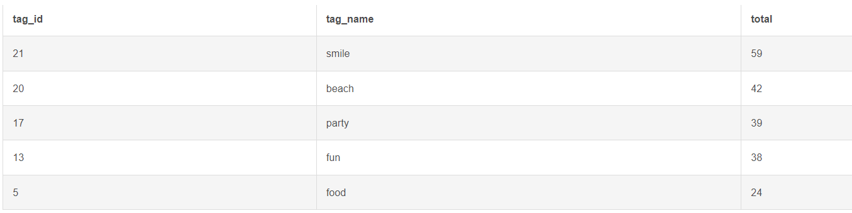

**AD campaign**

SELECT

DAYNAME(created_at) AS day_of_the_week,

COUNT(*) AS total_count

FROM ig_clone.users

GROUP by day_of_the_week

ORDER by total_count DESC;

**Result:**

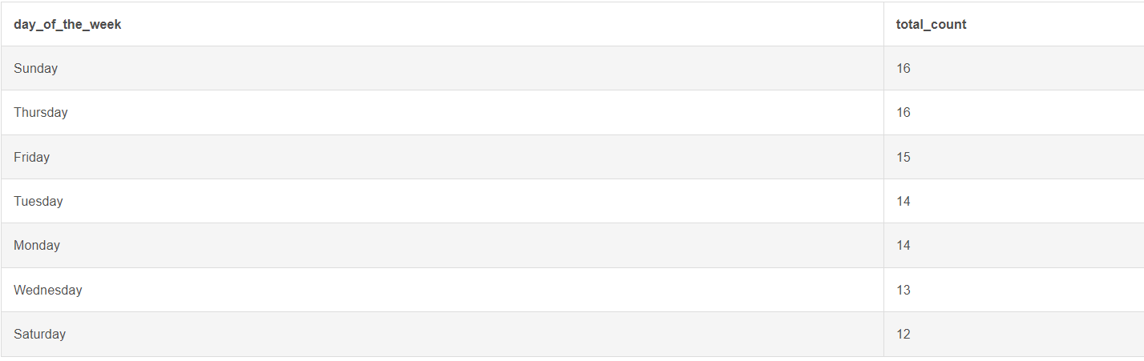

**B) Investor Metrics:**

1. **User Engagement**

SELECT

ROUND(

( SELECT COUNT(*) FROM ig_clone.photos ) / ( SELECT COUNT(*) FROM ig_clone.users ),

2

) AS avg_user_photo_post;

**Result:**

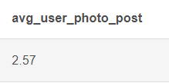

1. **Bot Accounts**

SELECT

ig_clone.users.id AS user_id,

ig_clone.users.username,

COUNT(*) AS total_user_likes

FROM ig_clone.users

JOIN ig_clone.likes

ON ig_clone.users.id = ig_clone.likes.user_id

GROUP BY users.id

HAVING total_user_likes = (

SELECT COUNT(*) FROM ig_clone.photos

)

**Result:**

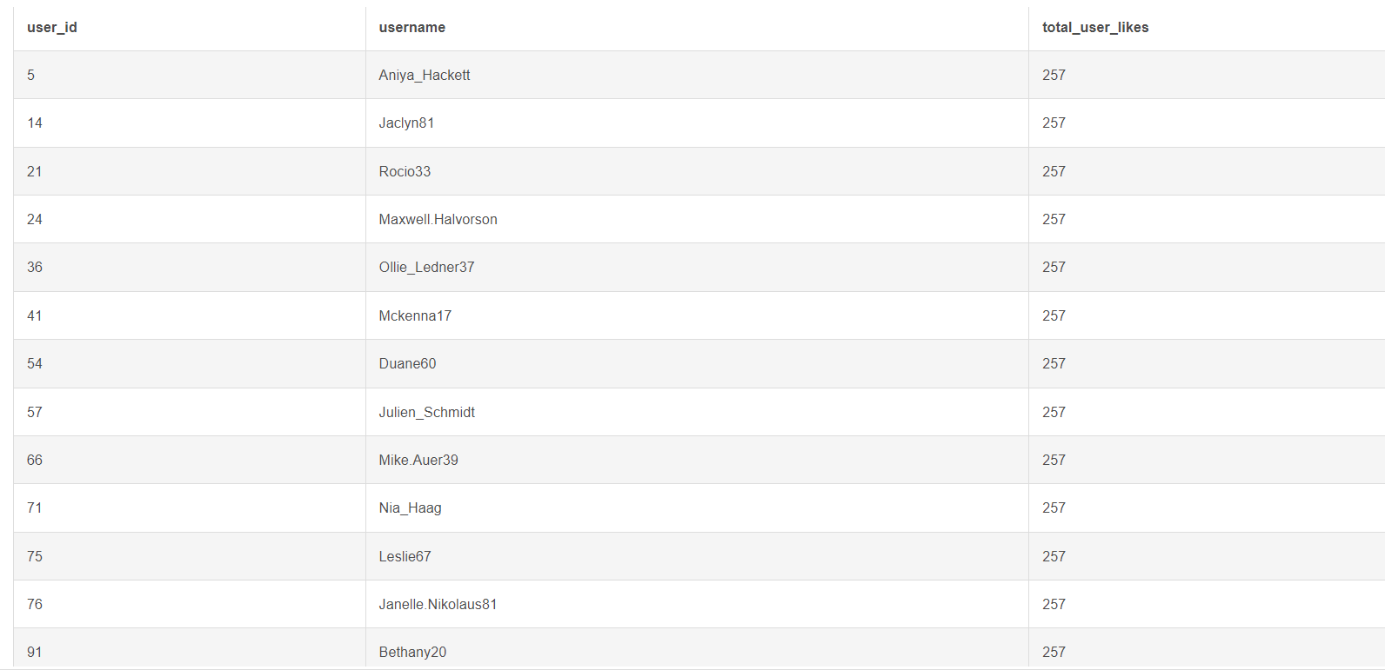

**Conclusion:**

Through this project, we were able to gain insights into how users think and behave when interacting with a product. We discovered a number of key insights about user behaviour, preferences, and expectations that can be used to inform future product design decisions. In particular, we identified trends in user behaviour that could be used to improve user experience, such as providing helpful feedback loops or streamlining processes for specific tasks. Overall, our user analysis project has provided us with valuable insights that can help us create better products in the future.